Polygon–Freeform Open Shapes
# Source: AI Source: Provided by: [Data Path: Persons Table -> ID Column: 1, Name_En Column: Motasem Essam] -> From: [ChatGPT] on [7/25/2026]
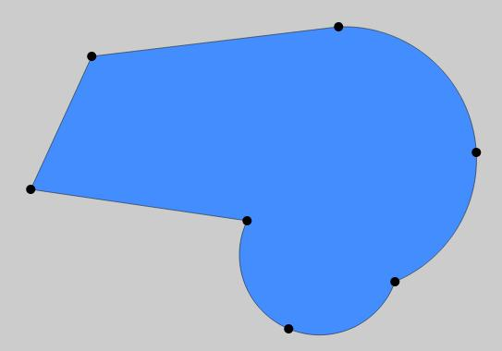
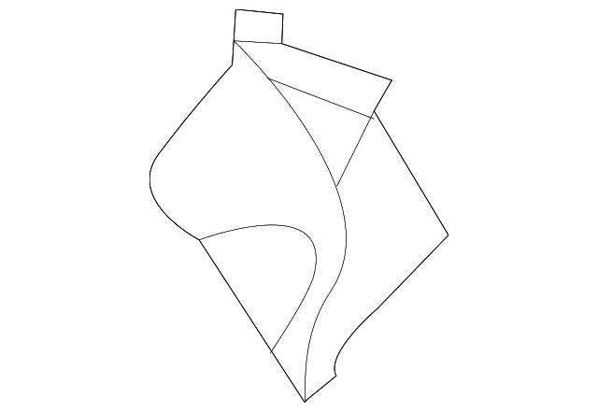
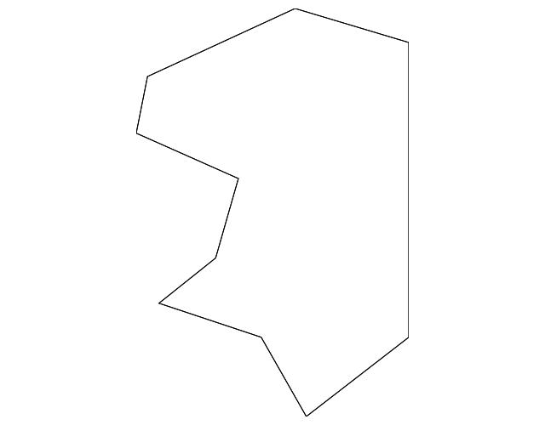

Definition
# Source: AI Source: Provided by: [Data Path: Persons Table -> ID Column: 1, Name_En Column: Motasem Essam] -> From: [ChatGPT] on [7/25/2026]
A Polygon–Freeform Open Shape is an open mixed shape that combines straight polygonal segments with freely designed curved or non-standard portions.
$$\boxed{\text{Polygon–Freeform Open Shape}=\text{Polygonal Segments}+\text{Freeform Portions}+\text{Open Boundary}}$$
The freeform portions are not required to be circular, elliptical, parabolic, or another standard geometric curve.

Characteristics
# Source: AI Source: Provided by: [Data Path: Persons Table -> ID Column: 1, Name_En Column: Motasem Essam] -> From: [ChatGPT] on [7/25/2026]
A Polygon–Freeform Open Shape:
- Is open.
- Contains straight polygonal segments.
- Contains one or more freely designed portions.
- May contain curved, wavy, irregular, or artistic sections.
- Is not restricted to a standard geometric equation.
- Has at least two endpoints.
- May contain sharp corners.
- May contain smooth transitions.
- Can be symmetric or asymmetric.
- Does not enclose an area by itself.

Types of Polygon–Freeform Open Shapes

1. Simple Polygon–Freeform Open Shape
# Source: AI Source: Provided by: [Data Path: Persons Table -> ID Column: 1, Name_En Column: Motasem Essam] -> From: [ChatGPT] on [7/25/2026]
A simple open path combining a few straight polygonal segments with a freely designed curved section.
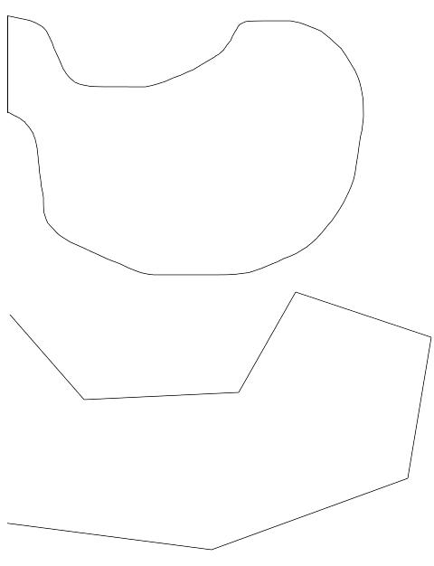
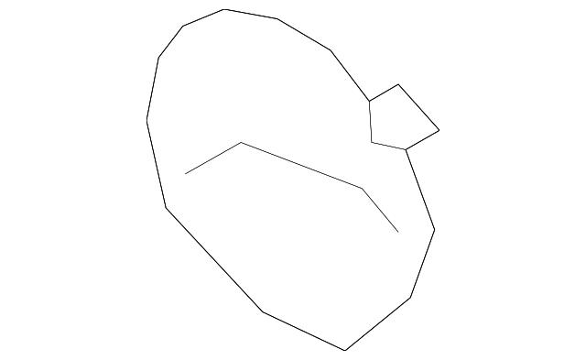

2. Irregular Polygon–Freeform Open Shape
# Source: AI Source: Provided by: [Data Path: Persons Table -> ID Column: 1, Name_En Column: Motasem Essam] -> From: [ChatGPT] on [7/25/2026]
An irregular open shape with unequal polygonal segments and freely varying curvature.
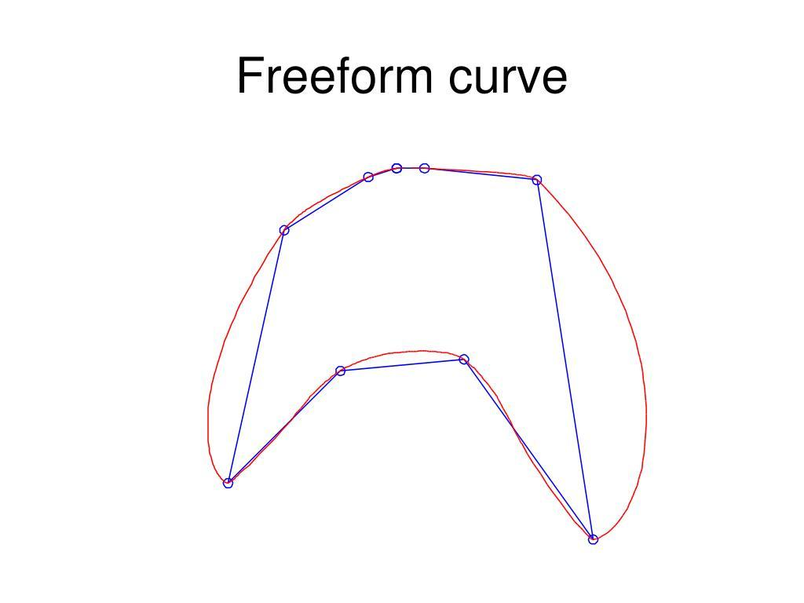
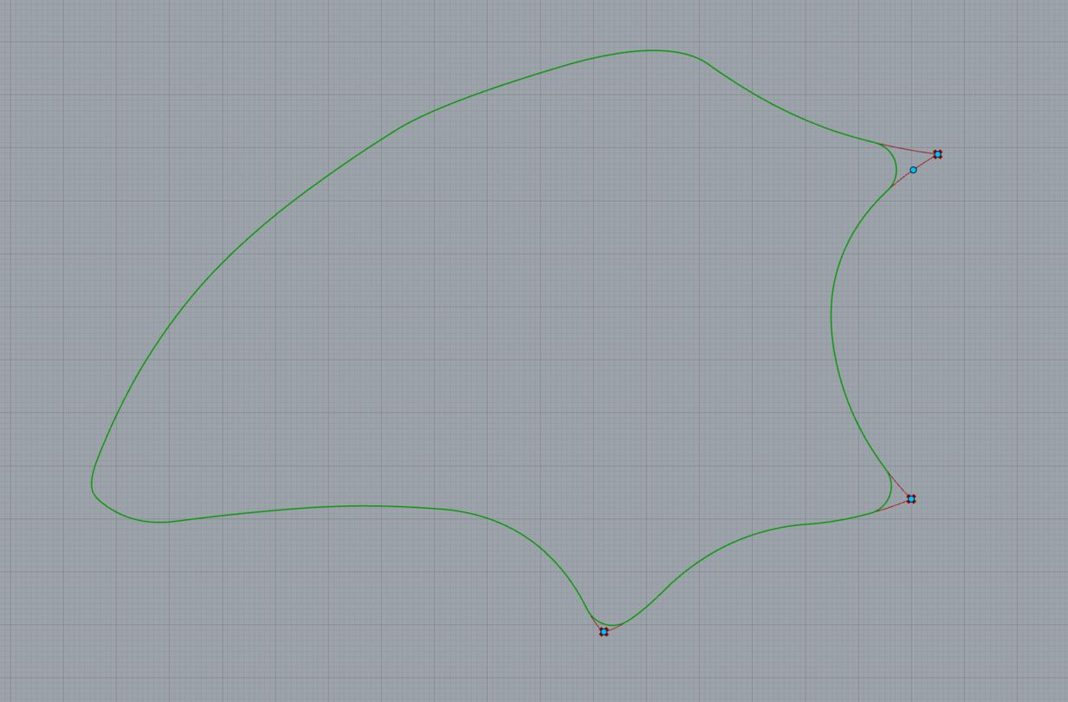
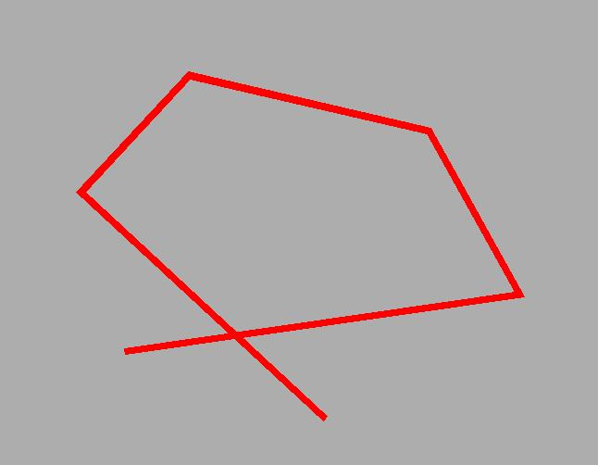

3. Smooth Polygon–Freeform Open Shape
# Source: AI Source: Provided by: [Data Path: Persons Table -> ID Column: 1, Name_En Column: Motasem Essam] -> From: [ChatGPT] on [7/25/2026]
The straight segments transition into smooth, freely controlled curves.
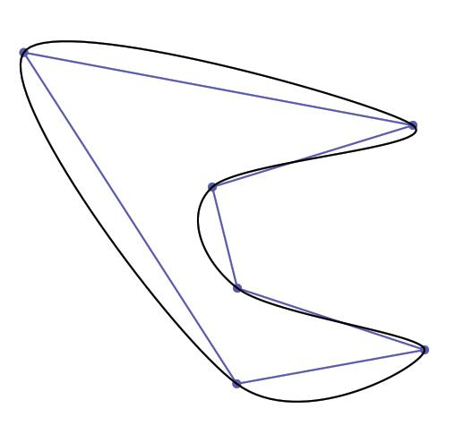
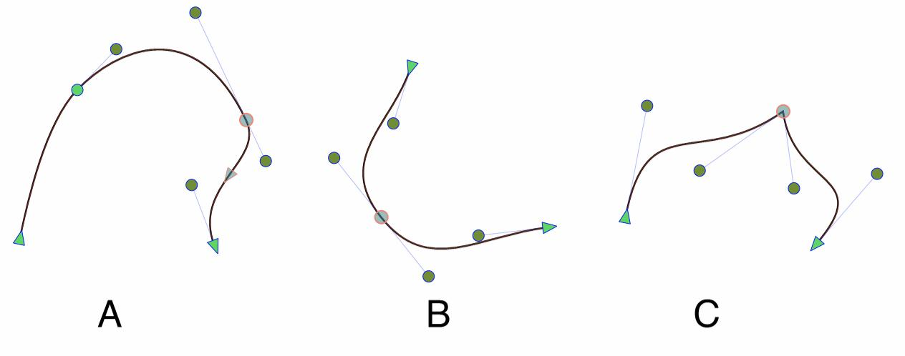
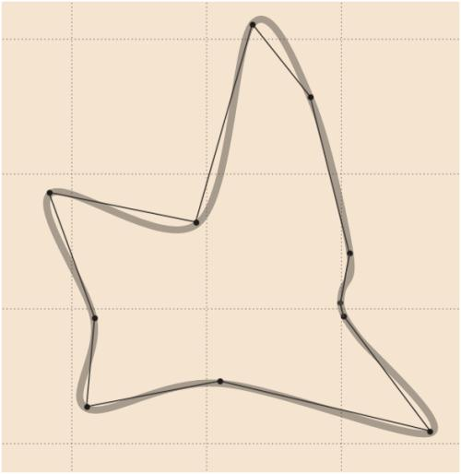

4. Wavy Polygon–Freeform Open Shape
# Source: AI Source: Provided by: [Data Path: Persons Table -> ID Column: 1, Name_En Column: Motasem Essam] -> From: [ChatGPT] on [7/25/2026]
The freeform portion contains irregular waves or undulations.
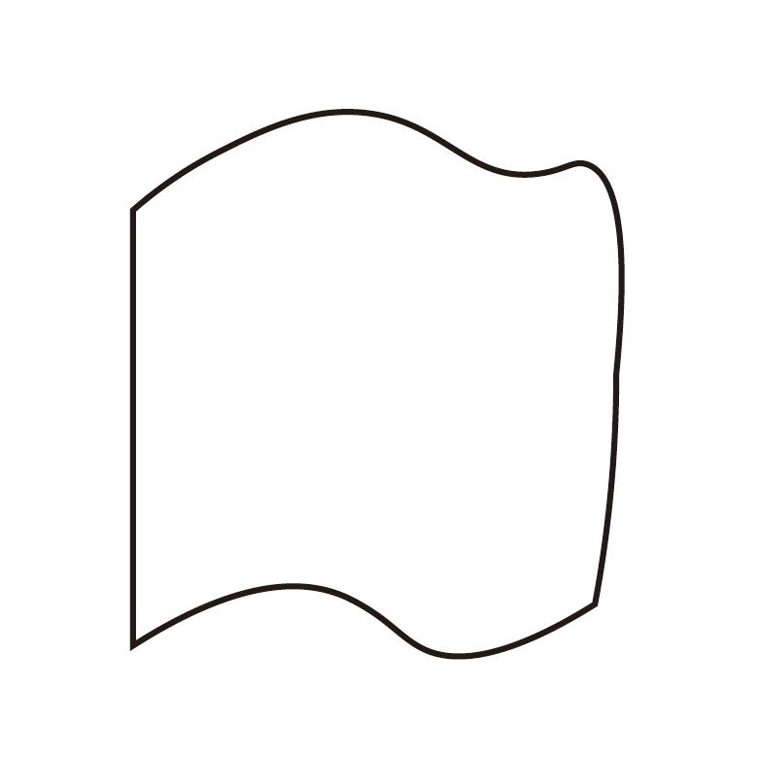
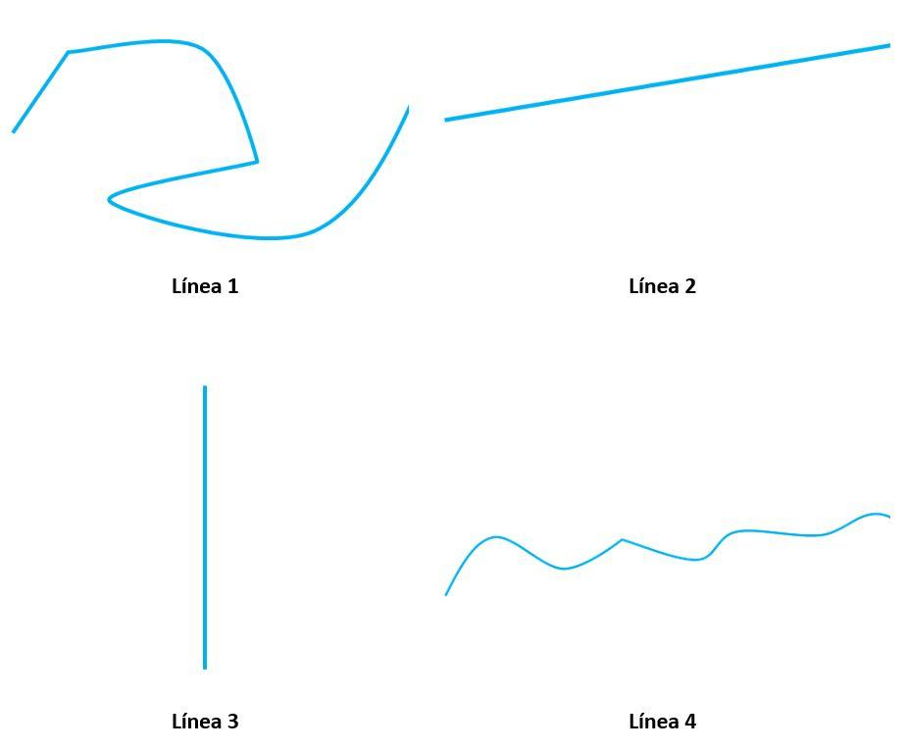

5. Spiral-Like Polygon–Freeform Open Shape
# Source: AI Source: Provided by: [Data Path: Persons Table -> ID Column: 1, Name_En Column: Motasem Essam] -> From: [ChatGPT] on [7/25/2026]
The freeform portion winds around a region in a spiral-like manner without necessarily following a mathematical spiral.
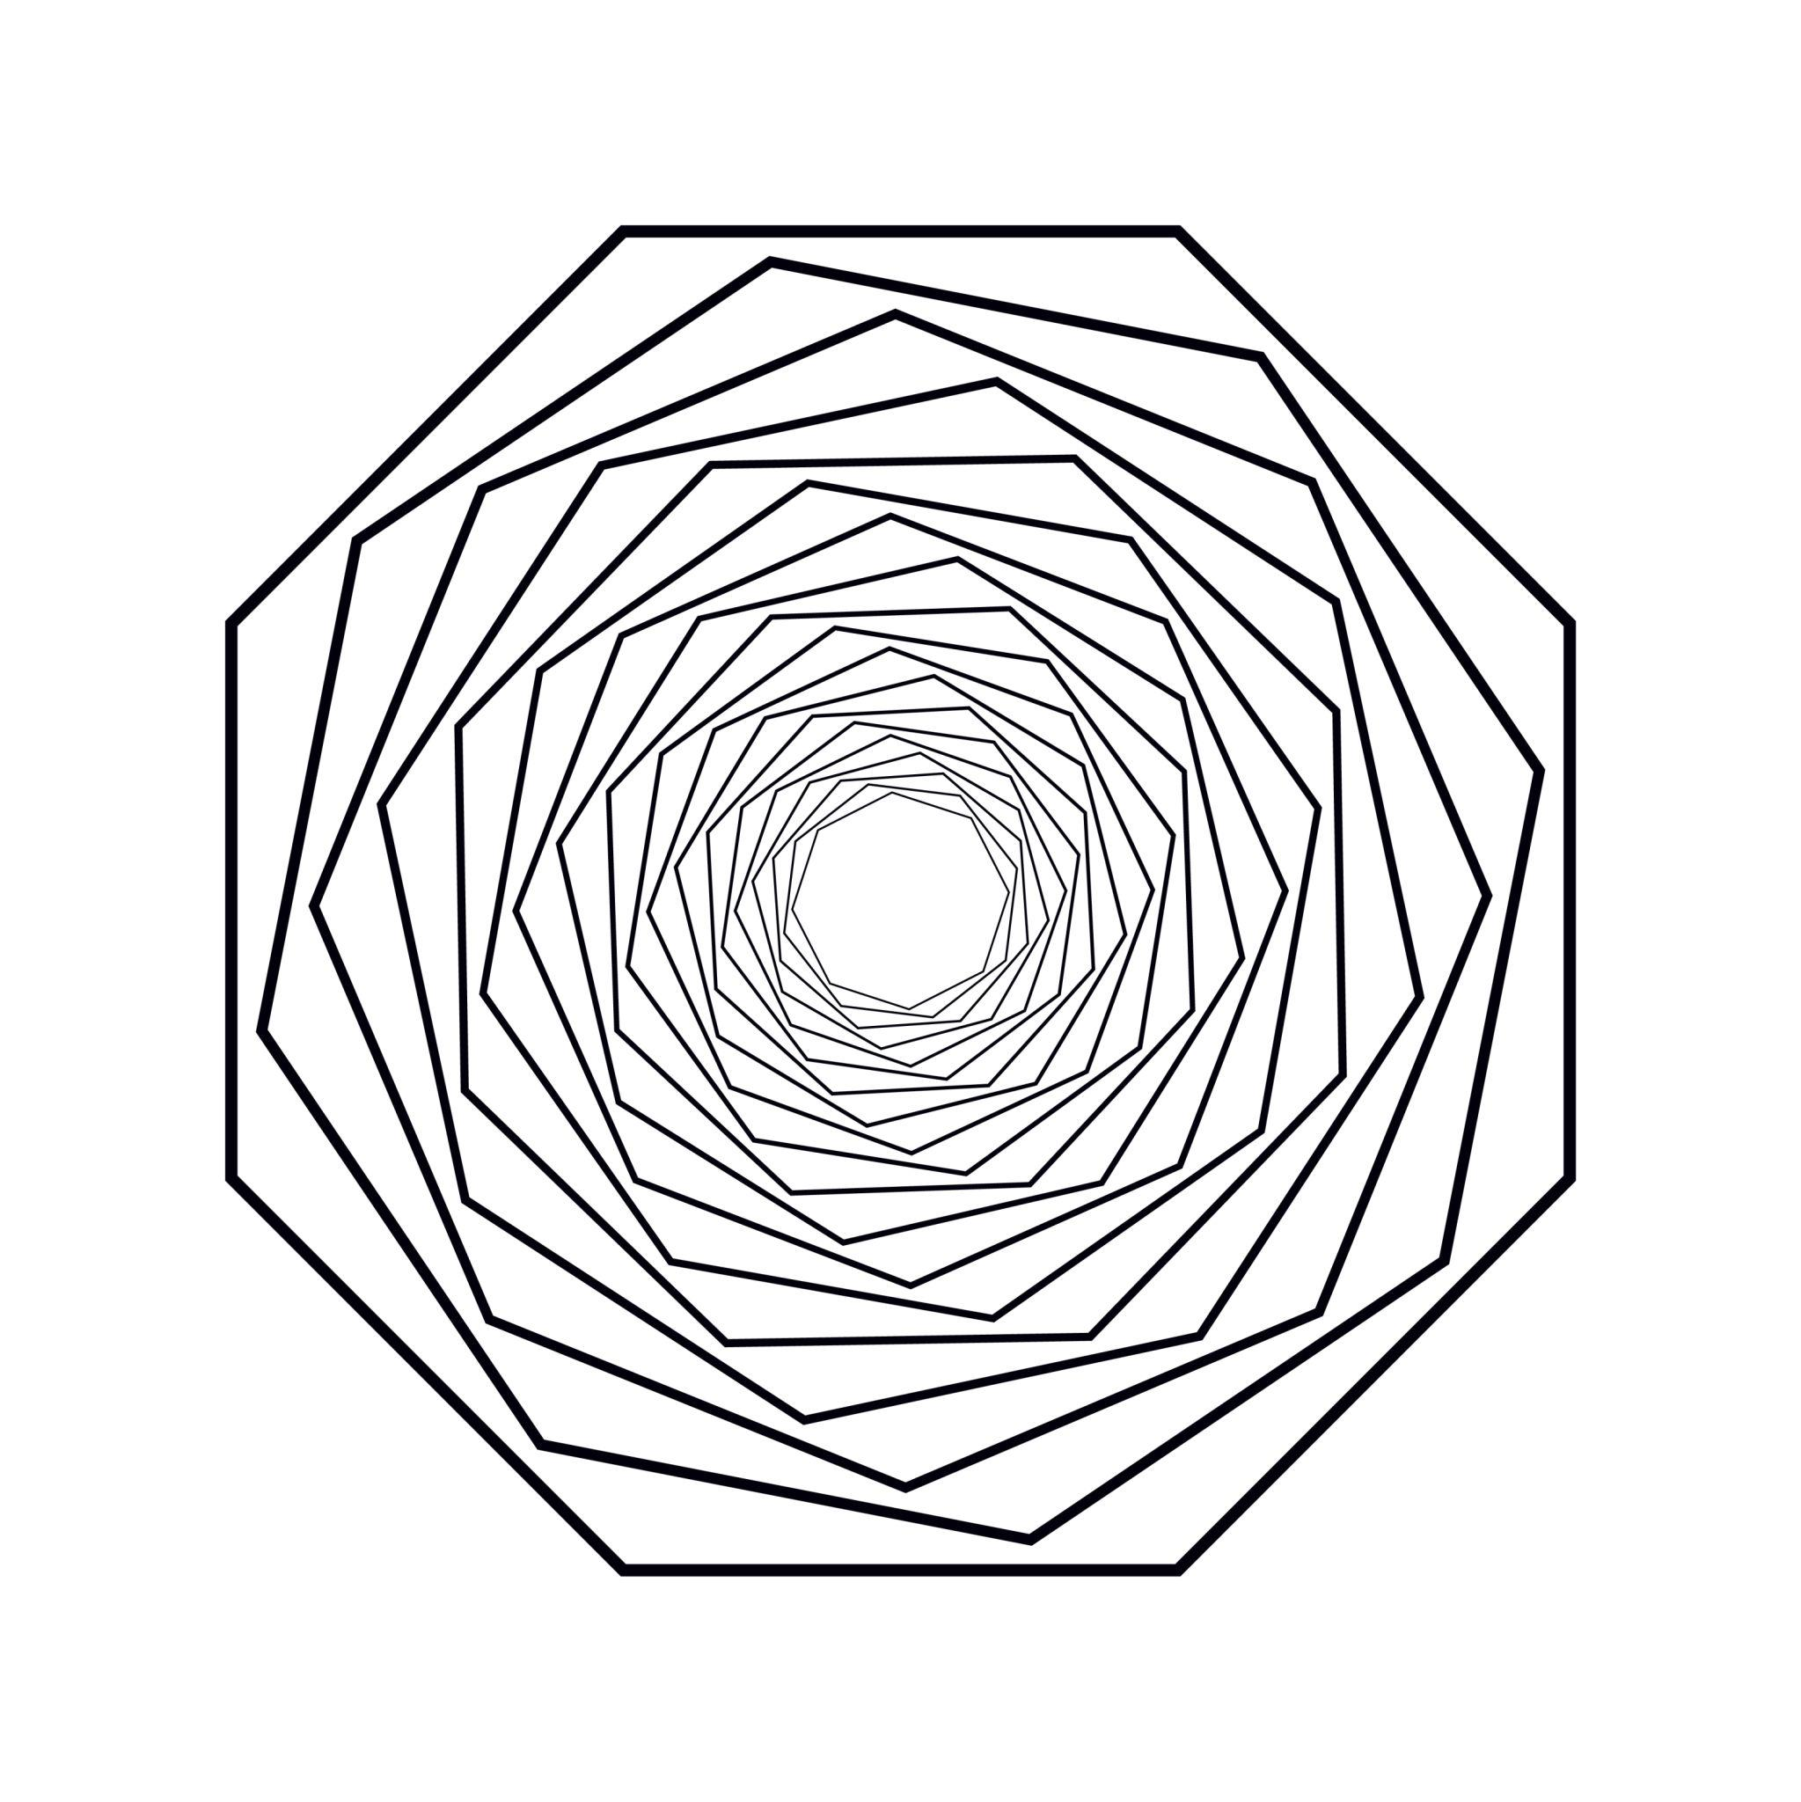
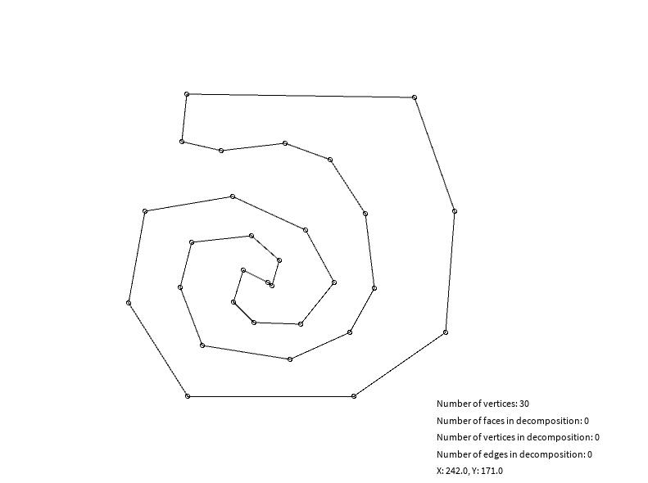
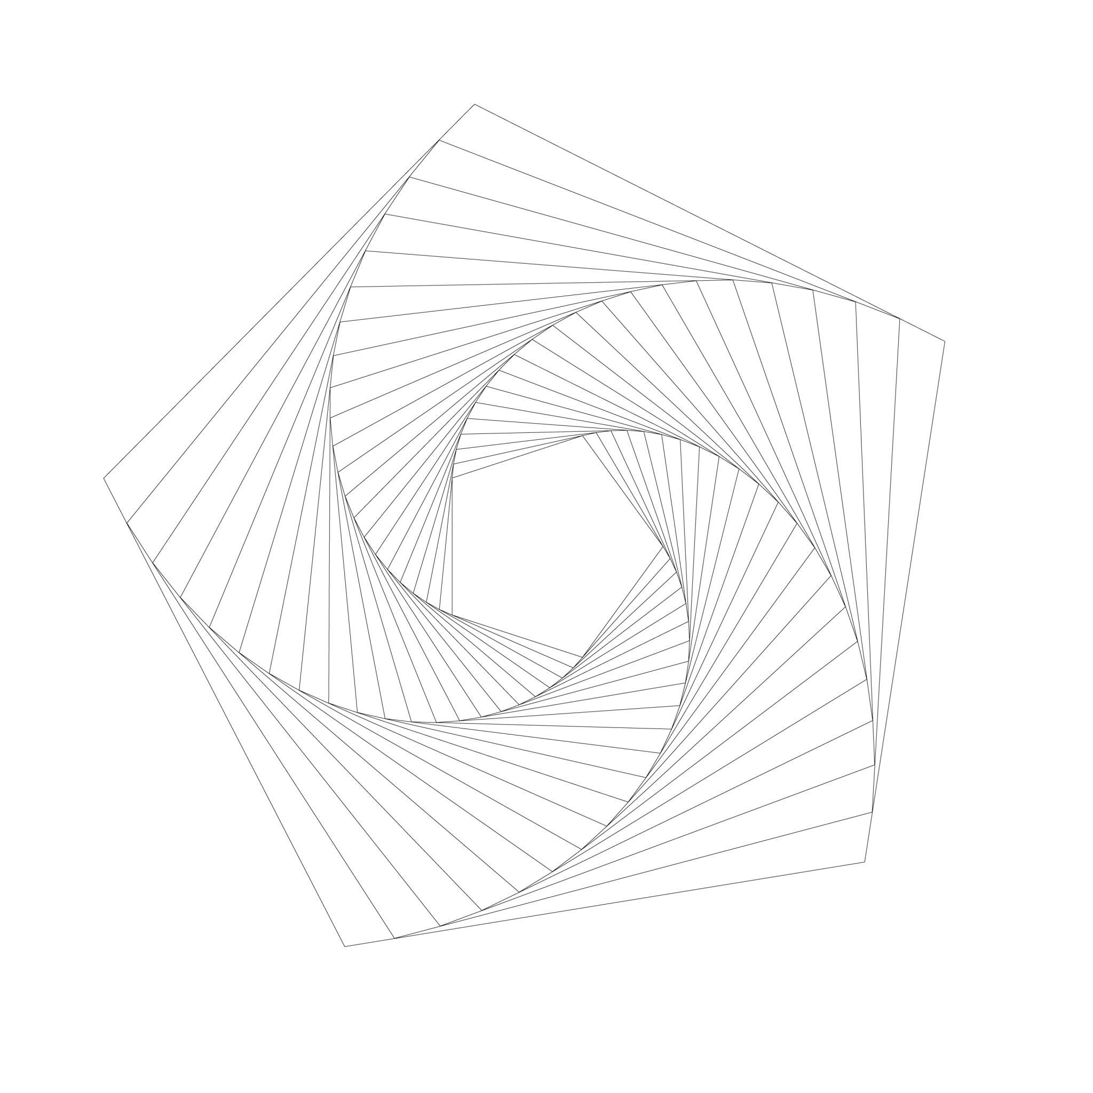
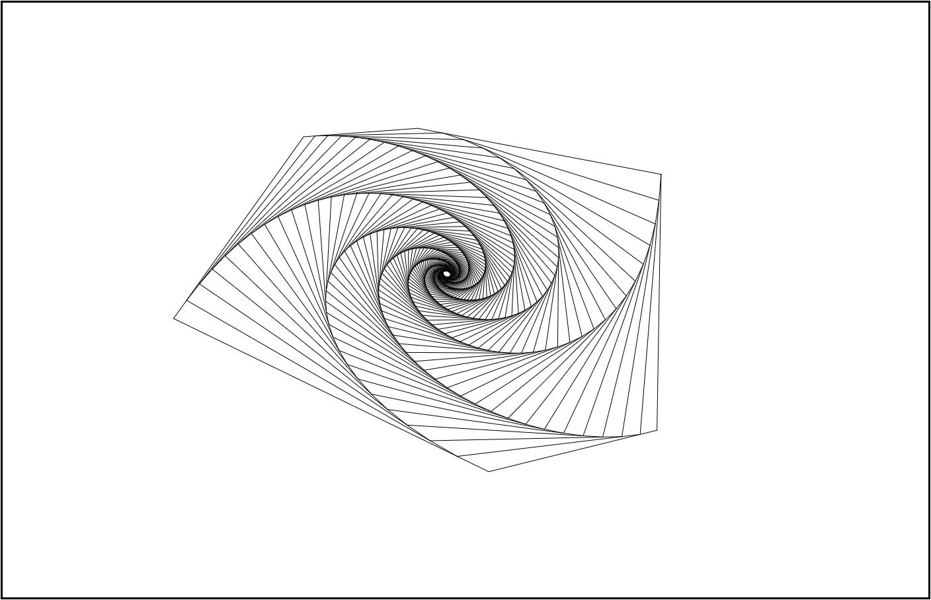
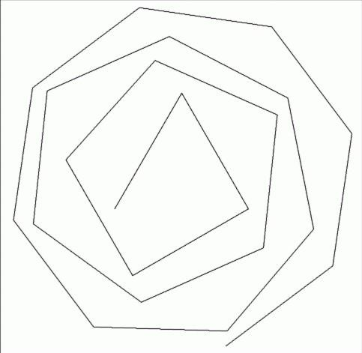

6. Asymmetric Polygon–Freeform Open Shape
# Source: AI Source: Provided by: [Data Path: Persons Table -> ID Column: 1, Name_En Column: Motasem Essam] -> From: [ChatGPT] on [7/25/2026]
The polygonal and freeform portions have no recognizable symmetry.
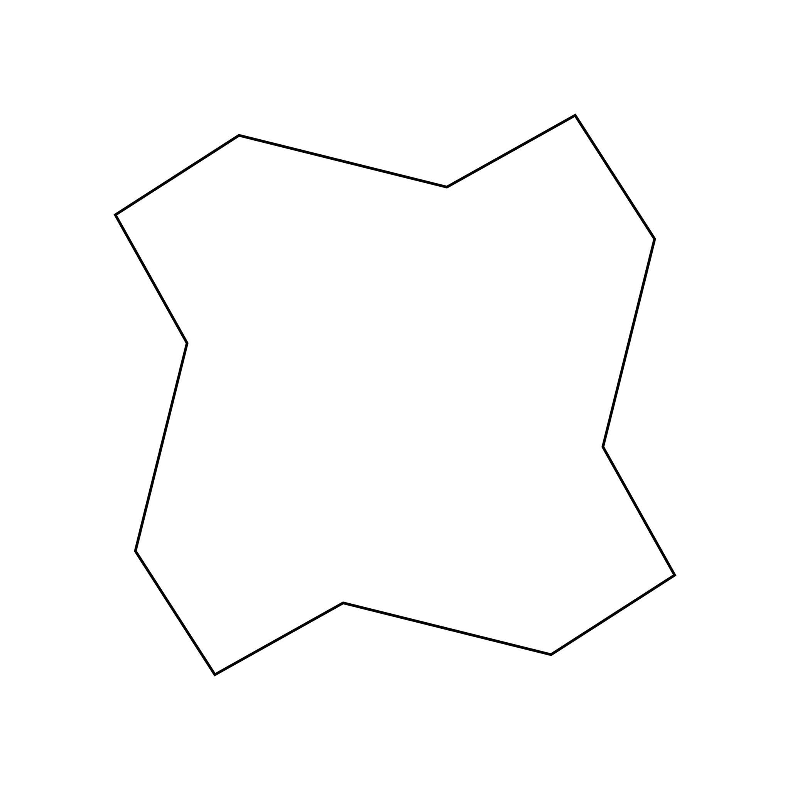
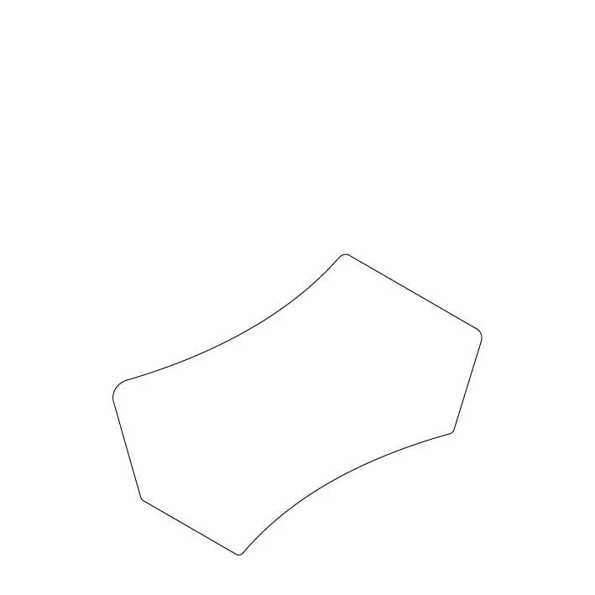
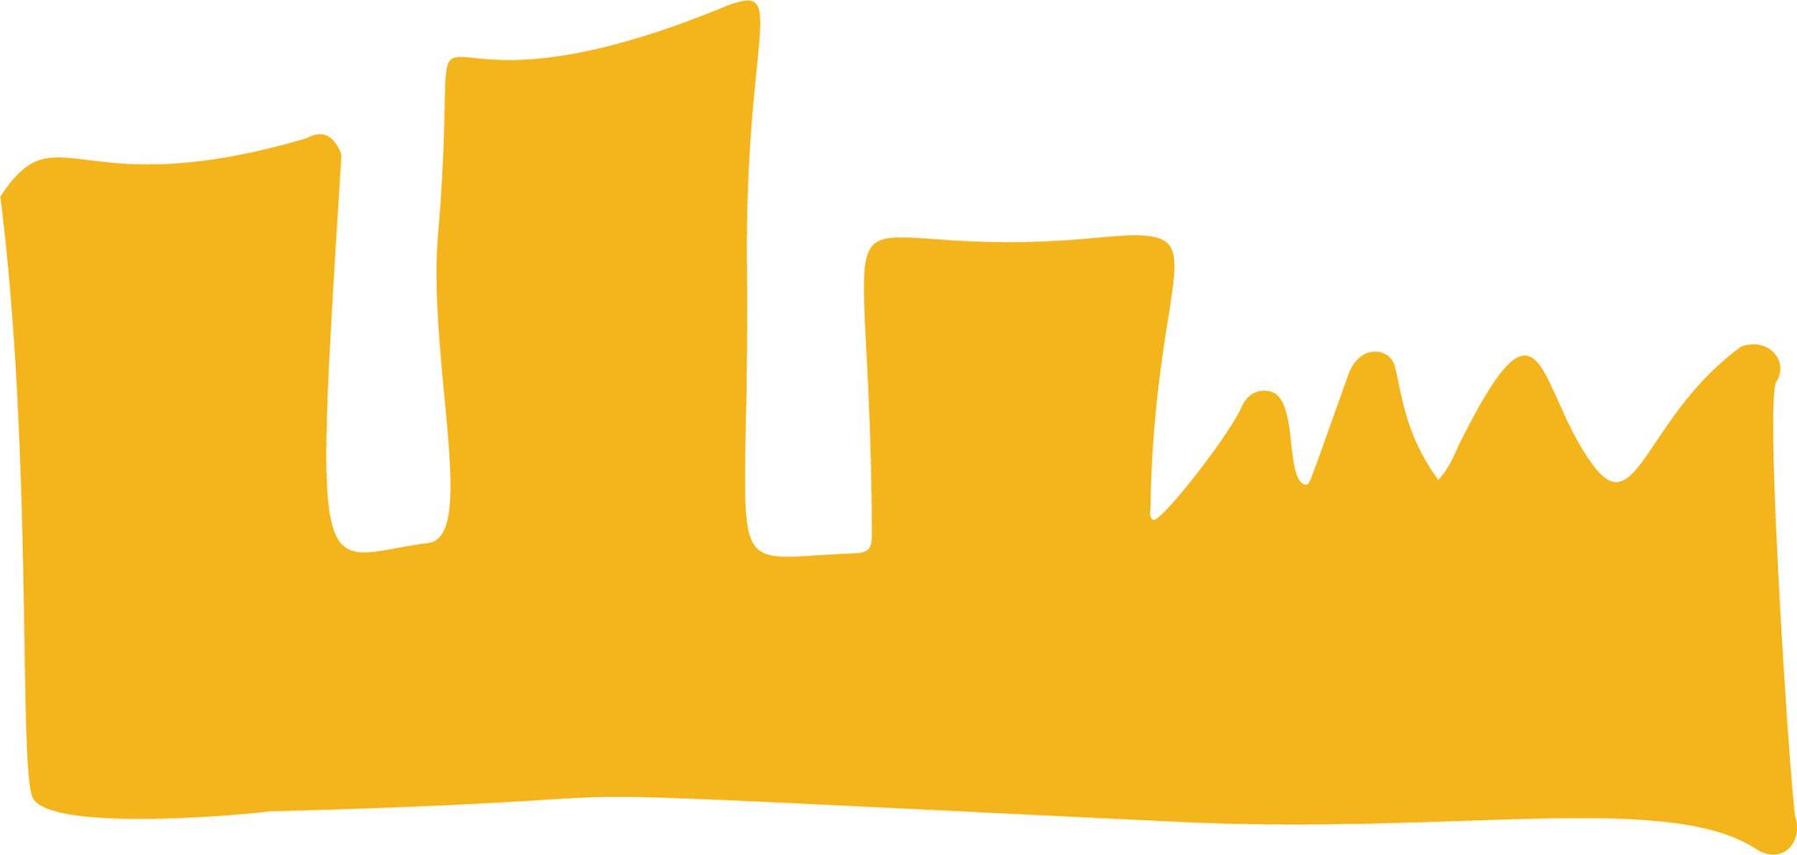

7. Symmetric Polygon–Freeform Open Shape
# Source: AI Source: Provided by: [Data Path: Persons Table -> ID Column: 1, Name_En Column: Motasem Essam] -> From: [ChatGPT] on [7/25/2026]
The overall combination has a recognizable axis or point of symmetry even though its freeform portion is not a standard geometric curve.
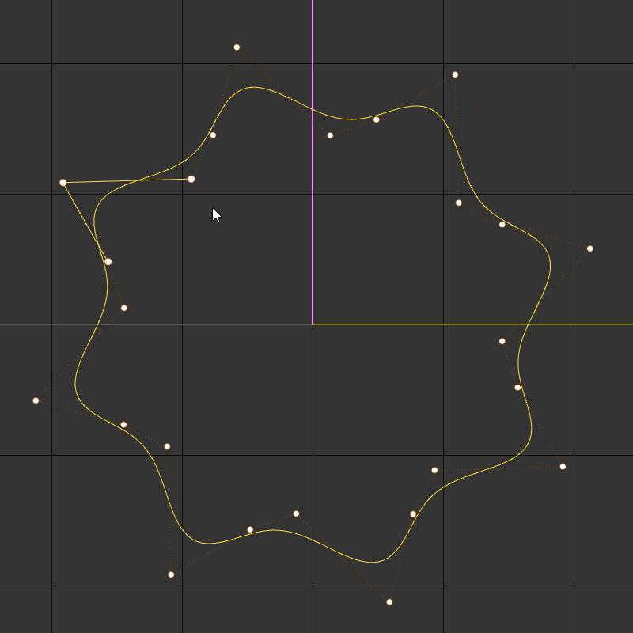

8. Multi-Curve Polygon–Freeform Open Shape
# Source: AI Source: Provided by: [Data Path: Persons Table -> ID Column: 1, Name_En Column: Motasem Essam] -> From: [ChatGPT] on [7/25/2026]
Several independent freeform curved sections are connected by straight polygonal segments.
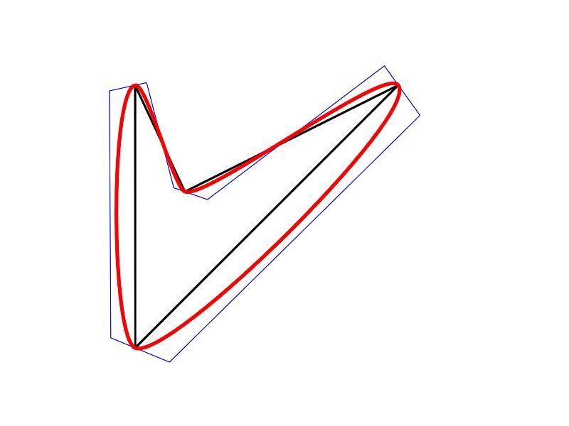

9. Multi-Bend Polygon–Freeform Open Shape
# Source: AI Source: Provided by: [Data Path: Persons Table -> ID Column: 1, Name_En Column: Motasem Essam] -> From: [ChatGPT] on [7/25/2026]
The path contains several straight and curved changes of direction.
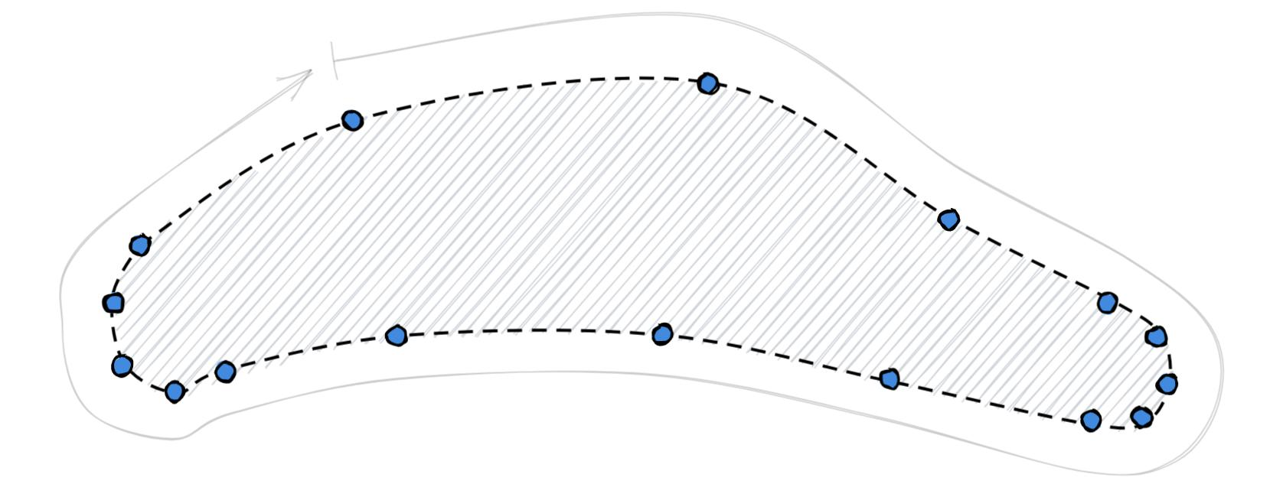

10. Cornered Polygon–Freeform Open Shape
# Source: AI Source: Provided by: [Data Path: Persons Table -> ID Column: 1, Name_En Column: Motasem Essam] -> From: [ChatGPT] on [7/25/2026]
The freeform portions meet polygonal segments at visible corners.
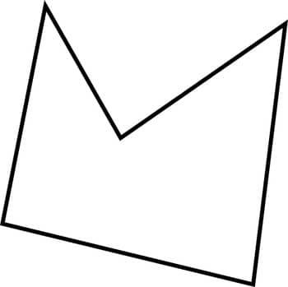
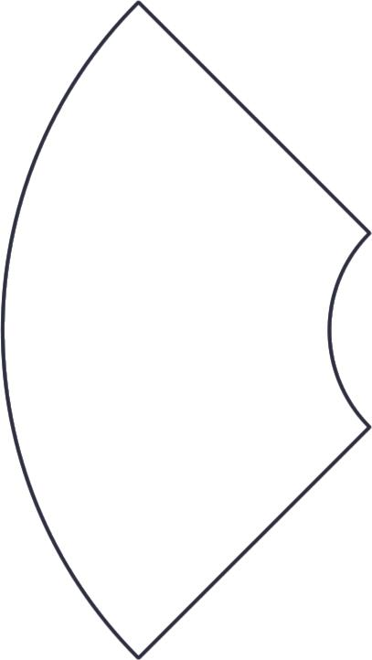

11. Tangential Polygon–Freeform Open Shape
# Source: AI Source: Provided by: [Data Path: Persons Table -> ID Column: 1, Name_En Column: Motasem Essam] -> From: [ChatGPT] on [7/25/2026]
A freeform curved section connects smoothly to a straight polygonal segment.
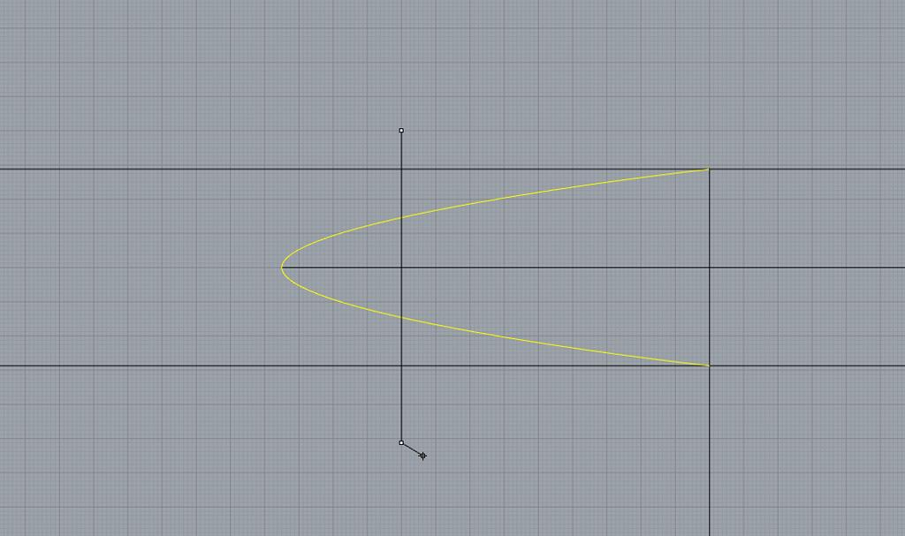
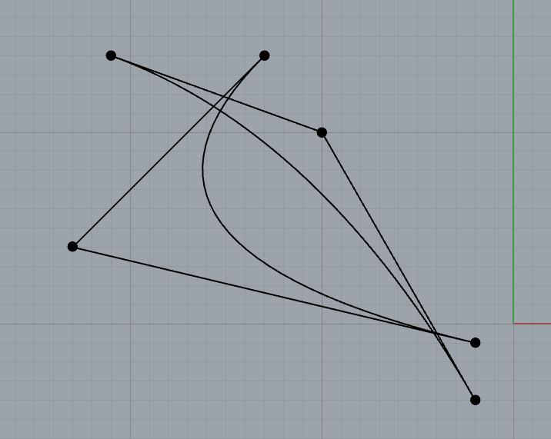

12. Artistic Polygon–Freeform Open Shape
# Source: AI Source: Provided by: [Data Path: Persons Table -> ID Column: 1, Name_En Column: Motasem Essam] -> From: [ChatGPT] on [7/25/2026]
A deliberately designed open path combining polygonal segments with artistic freeform curves.

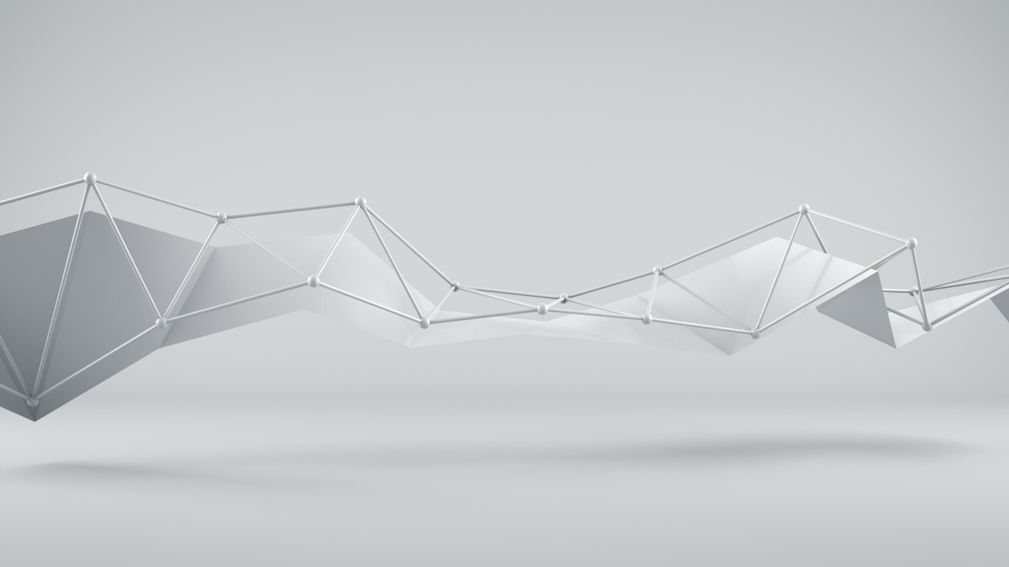
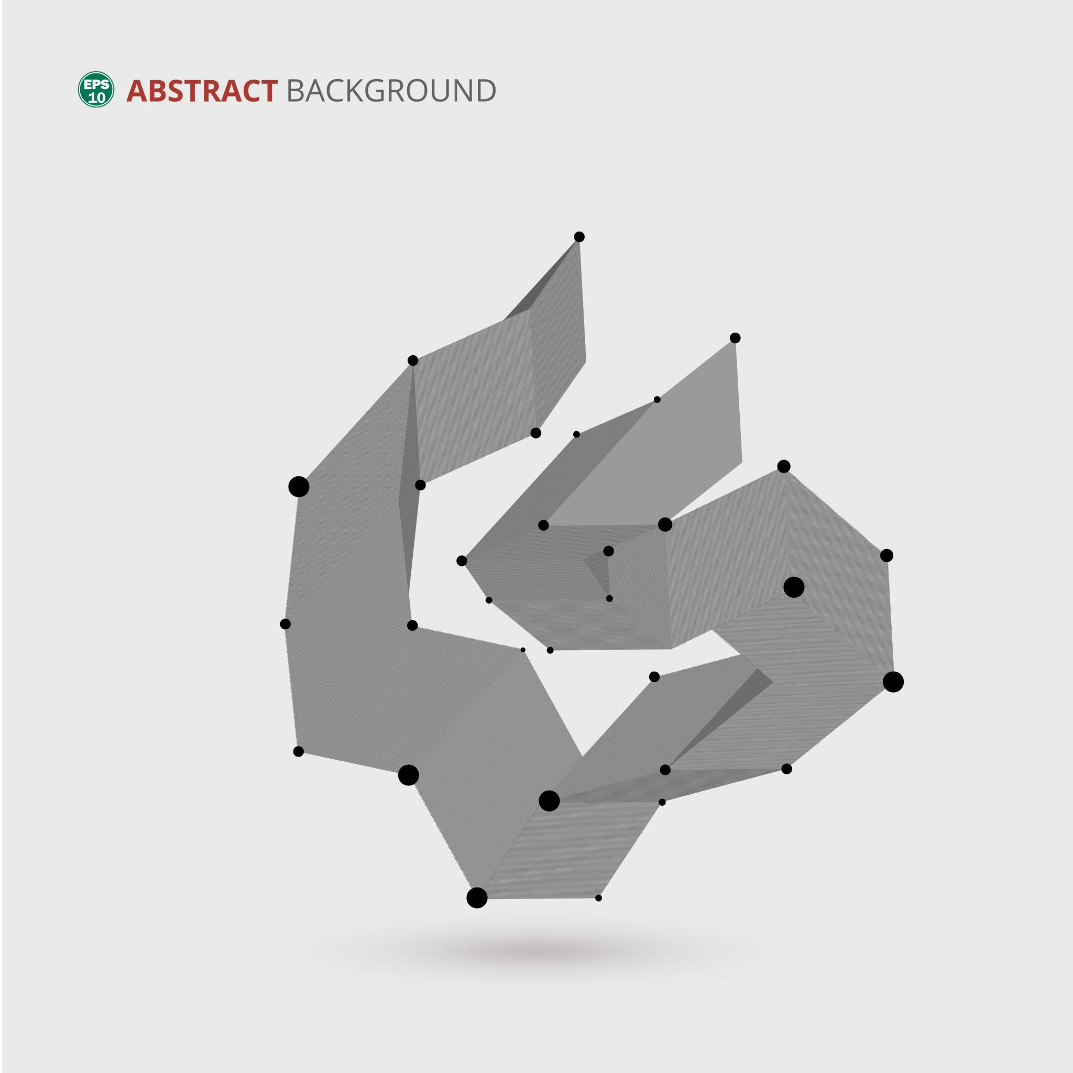


Polygon–Freeform vs. Polygon–Circular Open Shapes
# Source: AI Source: Provided by: [Data Path: Persons Table -> ID Column: 1, Name_En Column: Motasem Essam] -> From: [ChatGPT] on [7/25/2026]
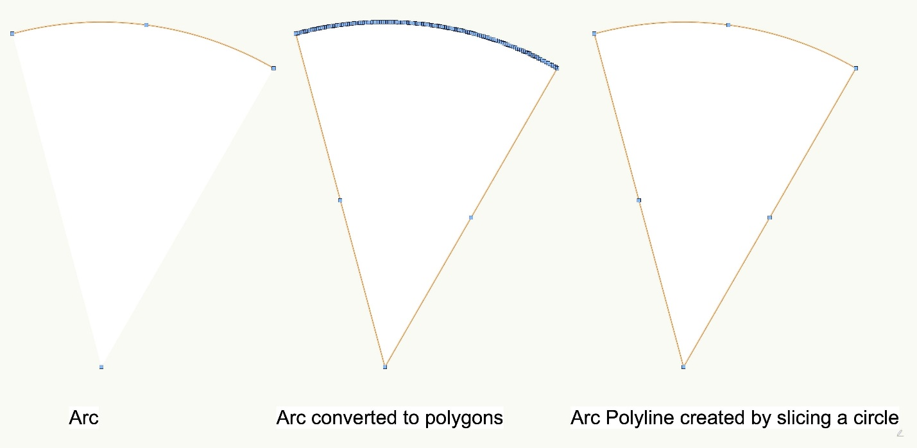
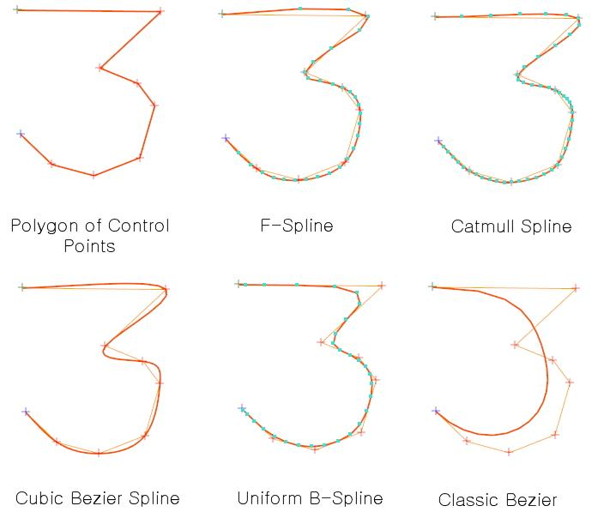
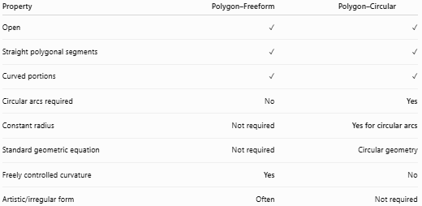
Property | Polygon–Freeform | Polygon–Circular
Open | ✓ | ✓
Straight polygonal segments | ✓ | ✓
Curved portions | ✓ | ✓
Circular arcs required | No | Yes
Constant radius | Not required | Yes for circular arcs
Standard geometric equation | Not required | Circular geometry
Freely controlled curvature | Yes | No
Artistic/irregular form | Often | Not required
Main distinction
$$\boxed{\text{Polygon–Freeform}=\text{Polygonal Segments + Freely Designed Portions}}$$
while:
$$\boxed{\text{Polygon–Circular}=\text{Polygonal Segments + Circular Arcs}}$$

Polygon–Freeform vs. Polygon–Organic Open Shapes
# Source: AI Source: Provided by: [Data Path: Persons Table -> ID Column: 1, Name_En Column: Motasem Essam] -> From: [ChatGPT] on [7/25/2026]
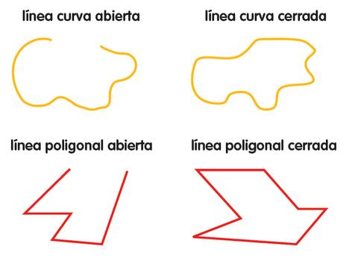
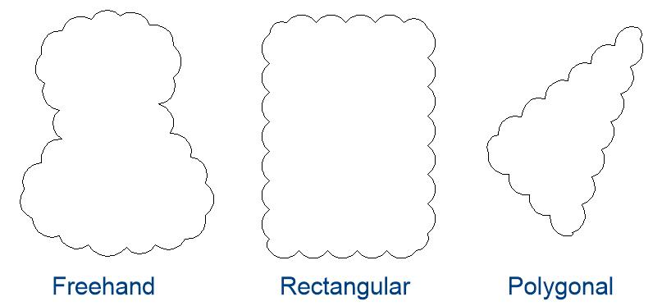
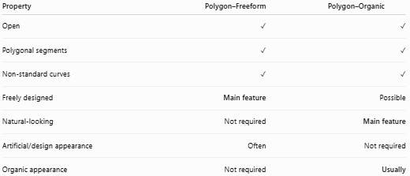
Property | Polygon–Freeform | Polygon–Organic
Open | ✓ | ✓
Polygonal segments | ✓ | ✓
Non-standard curves | ✓ | ✓
Freely designed | Main feature | Possible
Natural-looking | Not required | Main feature
Artificial/design appearance | Often | Not required
Organic appearance | Not required | Usually
The distinction is mainly about appearance and origin:
$$\boxed{\text{Freeform}=\text{Freely Designed}} \\ \boxed{\text{Organic}=\text{Natural-Looking}}$$

Key Points
# Source: AI Source: Provided by: [Data Path: Persons Table -> ID Column: 1, Name_En Column: Motasem Essam] -> From: [ChatGPT] on [7/25/2026]
A Polygon–Freeform Open Shape is:
$$\boxed{\text{Open}+\text{Polygonal}+\text{Freeform}}$$
It:
- Has straight polygonal segments.
- Contains at least one freely designed portion.
- Is not restricted to circular or other standard geometric curves.
- Has two or more endpoints.
- May contain smooth or sharp transitions.
- May be wavy, spiral-like, irregular, or artistic.
- Can be symmetric or asymmetric.
- Does not enclose an area by itself.

Conclusion
# Source: AI Source: Provided by: [Data Path: Persons Table -> ID Column: 1, Name_En Column: Motasem Essam] -> From: [ChatGPT] on [7/25/2026]
Polygon–Freeform Open Shapes combine the straight-sided structure of polygonal segments with freely designed non-standard portions. Their defining feature is the absence of a fixed geometric pattern for the freeform portions. This makes them different from Polygon–Circular Open Shapes, which specifically contain circular arcs, and from Polygon–Organic Open Shapes, where the curved portions are primarily characterized by a natural or organic appearance.

